Title of the 1-page Abstract
PresentingAuthorª, Author2ª, Author3^{b}
ª Organization, Address, Country
^{b} Organization, Address, Country

The length of the abstracts is strictly limited to one page, including figures and references. These guidelines are written in the desired format for the abstracts of the SLT. Please do not change any formatting. Please do not change the page margins.
Please save the abstract as a MS-Word file and name it with the name and the given name of the presenting author as indicated with the file name of this document.
You may add further affiliation lines if required. Please remove the second affiliation line and the referencing letter if all authors are with the same organisation. Please leave a blank line (Standard style) between the affiliation(s) and the beginning of the abstract.
Please insert your figure(s) at the end of the text of the abstract before the reference list, and leave a single blank line before and after the figure as shown with figure 1 below. Please make sure, that the figure is of appropriate quality and that any text in the figure is large enough to be read easily. The figure should be inserted into a single line without any wraparound of the text and have an appropriate figure caption.
References [1,2] are numbered, inserted in square brackets, and listed at the end of the abstract. Please insert one blank line before the reference list. The references should include the authors, the title between double quotes, the journal name, volume, pages, and the publication year in brackets as shown below.
Many thanks for keeping the formatting!

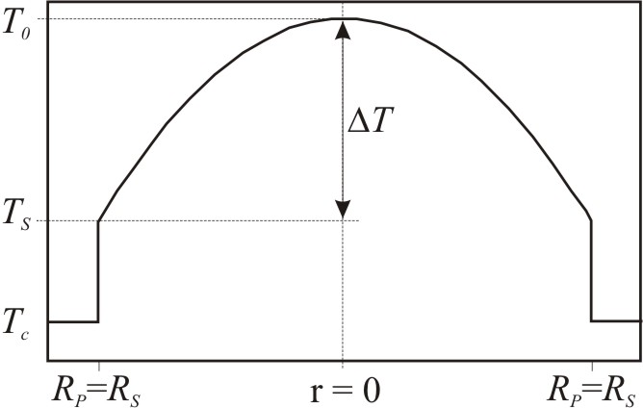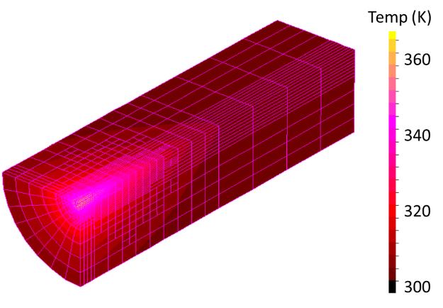

Figure 1. Left: Temperature distribution in a homogeneously pumped laser rod. Right: FE-modelling of the temperature distribution inside an end-pumped laser rod.

[1] Author, Author, Author, “Title of the paper”, Journal Volume, pages - pages (year)
[2] Author, Author, Author, “Title of the paper”, Journal Volume, pages - pages (year).

